BRAIN-TARGETED TEACHING
LEARNING UNIT

Teacher: Liz DeSell, Amber Kilcoyne, Andrea Kordonski Dates: 4 weeks
Unit Topic/Title: Tuck Everlasting Novel Study Grade Level: 5th
Standards:
Reading
(RL 5.2) Analyze details about characters, setting, and plot in a literary text to infer a theme
(RL.5.4.) Determine the meaning of words and phrases as they are used in a text, including figurative language such as metaphors and similes.
Writing
(W.5.2.) Write informative/explanatory texts to examine a topic and convey ideas and information clearly.
(W.5.3) Write narratives to develop real or imagined experiences or events using effective technique, descriptive details, and clear event sequences.
Science
(5.3.15.a.3) Compare and contrast the similarities and differences in life cycles of different organisms.

Brain Target #1
Emotional Connection:
1.) Begin unit by giving every child an unlabeled bottle of water. Place the bottles of water on their desk before they come to class. Ask students, “If you could live forever just by drinking this bottle of water, what would you do?” Allow students to respond to the question in their journal. Give students time to share responses with the classroom. Ask: “Who do think would/would not like to live forever? Why?”
2.) The second day of the unit the students will enter the classroom to the sound of a music box. Ask students what the music reminds them of or what it sounds like. Display the music box for the students to see. Explain that music boxes during this time period were special and intricately made.
3.) Writing activity: Students will write a journal entry through Winnie’s eyes about being kidnapped. Students will reflect and write about the experience.
4.) Tableau: Students will use facial expressions to represent how they think Winnie reacted when she found out the Tucks could live forever.
5.) Take the students on a nature walk around the school grounds.

Brain Target #2
Physical Environment:
1.) Begin the unit by transforming classroom into the forest like the setting in the novel.
2.) Arrange for flexible seating and provide times during the day to move to the different centers around the room.
3.) Students will use visualization to paint a picture of the forest where the spring is located during art class. The teacher will hang out student created work.
4.) Utilize the “Question/Concept” board to address relevant concern, questions, and ideas as they arise during the unit study.
5.) Create a display outside the classroom for school community to read the legends created by the students (See activities from BT-5).
6.) Anchor chart on theme (See activity from BT-4).

Brain Target #3
Concept Map / Advanced Organizer:
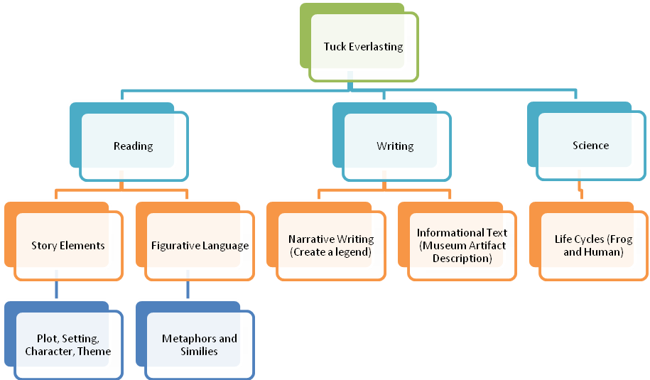

Learning Goals: Students will be able to:
1.) Identify the characters, setting, plot, and theme in a literary work.
2.) Identify figurative language that contributes to meaning of the story.
3.) Create a narrative story.
4.) Describe key aspects of the human life cycle.
5.) Write an informative text.

Introductory “Big Picture” Activity/Assessment of Prior Knowledge
Begin the unit by playing the song, “Circle Game” by Joni Mitchell. Discuss stages of life the song includes and make a list on the board. Discuss questions: Is the use of a carousel to present the circle of life an effective symbol? Why or why not? Students will work with a partner to create additional verses to the song about what the man discovers as he ages.

Brain Target #4
Activities for Teaching Declarative/Procedural Knowledge
1.) Analyze characters in the story using character maps. Compare and contrast character traits.
2.) Students will identify and interpret similes and metaphors from the book.
3.) Compare and contrast the Tuck family’s life cycle with a regular human’s life cycle using Venn Diagram.
4.) Students will take their narrative writing piece through the stages of the writing process during center time. Students will be provided feedback from the teacher and support as they create their legend.
5.) Build understanding of theme by discussing the movie “The Lorax.” Ask students to brainstorm what the “big picture” of the movie was. Tell students that “big picture” of a movie, book, song, etc. is called the theme. Give students 3 themes and ask them to generate examples of movies, books, songs, or other things that contain that theme. Allow students to share responses and build a theme anchor poster.

Brain Target #5
Activities for Extension and Application of Knowledge
1.) As an end of unit project students will create an object for a “museum” of Tuck Everlasting. Students will need to make sure their object represents symbols, themes, characters, or events from the novel. Students will an informational paragraph to describe their artifact and explain the importance of the object.
2.) Students will apply knowledge of similes and metaphors by writing their own poem incorporating both types of figurative language into a poem.
3.) At the end of the unit, students will reflect back on their first journal entry of the unit.
4.) Students will write the legend of how the spring came to be. Students will incorporate the literacy elements (setting, characters, and plot) to develop their legend.

Brain Target #6
Evaluating Learning
1.) Give students an end of unit test on human life cycles.
2.) Students will be assessed using a rubric to evaluate their narrative writing piece of the legend of the spring.
3.) Teachers will keep anecdotal records on students’ progress and check for their understanding on key concepts.
4.) Students will be assessed using a rubric to evaluate their informative writing about their museum piece for the Tuck museum.
5.) Informally assess students’ writing progress during individual writing conferences during workshop time.

Materials:

Tuck Everlasting by Natalie Babbitt
“Circle Game” by Joni Mitchell

